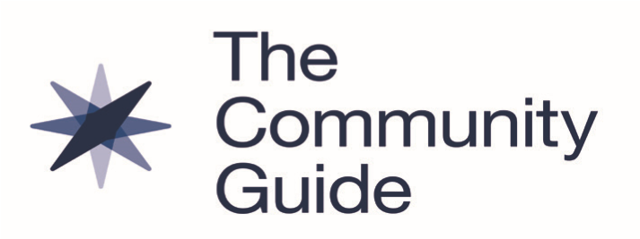

Cancer Screening: Patient Navigation Services to Increase Colorectal Cancer Screening and Advance Health Equity

January 2023

Summary of Community Preventive Services Task Force Recommendation *
The Community Preventive Services Task Force (CPSTF) recommends patient navigation services to increase colorectal cancer screening by colonoscopy, fecal occult blood test (FOBT) or fecal immunochemical test (FIT), among historically disadvantaged racial and ethnic populations and people with lower incomes. Patient navigation services are expected to advance health equity when implemented among these populations who often have lower screening rates.¹
CPSTF also recommends patient navigation services to increase breast and cervical cancer screening.
Major Findings *
The CPSTF recommendation is based on evidence from a systematic review of 27 studies.
- Patient navigation interventions increased colorectal cancer screenings using
  - Tests recommended by the U.S. Preventive Services Task Force by a median of 13.6 percentage points or 76.2%; the included studies did not specify the type of test used (26 studies).
  - Colonoscopy increased by a median of 13.9 percentage points or 109.9% (12 studies)
  - FOBT or FIT increased by a median of 12.4 percentage points or 57.3% (12 studies)

What are Patient Navigation Services? *
Healthcare systems provide patient navigation services to help patients overcome barriers to accessing colorectal cancer screening. Services are often offered to populations experiencing greater disparities in cancer screening, including people from historically disadvantaged racial and ethnic populations and people with lower incomes. They include client reminders, reduced structural barriers or improved assistance getting around them, reduced out-of-pocket costs, or a combination of these approaches. Services may also provide one-on-one or group education.
Patient navigation services are delivered by community health workers, patient navigators, healthcare professionals, nurses, social workers, or others. They are often designed to be culturally- and language-appropriate.

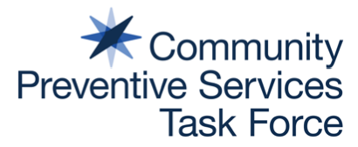

Facts About Colorectal Cancer
- Colorectal cancer is the fourth most common cancer in adults.²
- Screening can find precancerous polyps—abnormal growths in the colon or rectum—so they can be removed before turning into cancer. Screening also helps find colorectal cancer at an early stage, when treatment often leads to a cure.¹
- In 2018, colorectal cancer screening rates in the United States were below Healthy People 2020 targets. Rates were even lower among people from historically disadvantaged racial and ethnic groups, people with lower incomes, and people who were uninsured.³
Learn More
*Read a complete summary of the systematic review and CPSTF finding.
www.thecommunityguide.org/findings/cancer-screening-patient-navigation-services-to-increase-colorectal-cancer-screening.html
The Community Guide, What Works to Increase Cancer Screening
www.thecommunityguide.org/resources/what-works-cancer-screening.html

CDC Colorectal Cancer
www.cdc.gov/cancer/colorectal/

National Cancer Institute, Evidence-based Cancer Control Programs (EBCCP)
https://ebccp.cancercontrol.cancer.gov/index.do

References
¹ Centers for Disease Control and Prevention (CDC). Screen for Life: National Colorectal Cancer Action Campaign. Atlanta (GA): 2022. Retrieved from: www.cdc.gov/cancer/colorectal/sfl/.
² U.S. Cancer Statistics Working Group. U.S. Cancer Statistics Data Visualizations Tool, based on 2019 data. CDC and National Cancer Institute: 2019. Accessed Sept 29, 2022. www.cdc.gov/cancer/dataviz.
³ Sabatino SA, Thompson TD, White MC et al. Cancer screening test receipt - United States, 2018. MMWR 2021;70(2):29-35.

Established in 1996 by the U.S. Department of Health and Human Services, the Community Preventive Services Task Force
(CPSTF) is an independent, nonfederal panel of public health and prevention experts whose members are appointed by the
director of CDC. CPSTF provides information for a wide range of decision makers on programs, services, and other interventions aimed at improving population health. Although CDC provides administrative, scientific, and technical support for CPSTF, the recommendations developed are those of CPSTF and do not undergo review or approval by CDC. Find more information at www.thecommunityguide.org.

