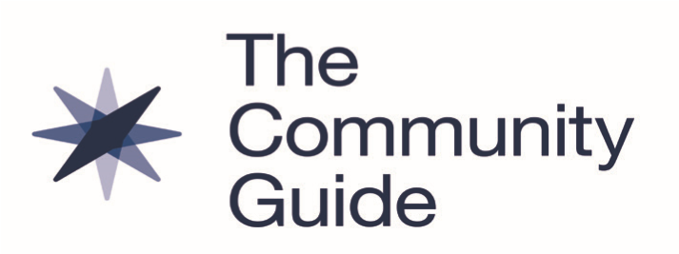

Cancer Screening: Patient Navigation Services to Increase Breast Cancer Screening and Advance Health Equity

January 2023

Summary of Community Preventive Services Task Force Recommendation *
The Community Preventive Services Task Force (CPSTF) recommends patient navigation services to increase breast cancer screening by mammography among historically disadvantaged racial and ethnic populations and people with lower incomes. Patient navigation services are expected to advance health equity when implemented among these populations who often have lower screening rates.¹
CPSTF also recommends patient navigation services to increase cervical and colorectal cancer screening.
Major Findings *
The CPSTF recommendation is based on evidence from a systematic review of 11 studies. Patient navigation interventions increased breast cancer screening by a median of 12.0 percentage points or 54.5%.
.
What are Patient Navigation Services? *
Healthcare systems provide patient navigation services to help patients overcome barriers to accessing breast cancer screening. Services are often offered to populations experiencing greater disparities in cancer screening, including people from historically disadvantaged racial and ethnic populations and people with lower incomes. They include client reminders, reduced structural barriers or improved assistance getting around them, reduced out-of-pocket costs, or a combination of these approaches. Services may also provide one-on-one or group education.
Patient navigation services are delivered by community health workers, patient navigators, healthcare professionals, nurses, social workers, or others. They are often designed to be culturally- and language-appropriate.

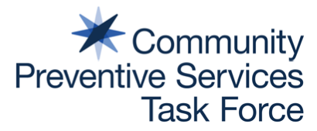
Facts About Breast Cancer
- Breast cancer is the second leading cause of cancer death among women in the United States. About 264,000 women are diagnosed with breast cancer each year and approximately 42,000 women die from the disease.²
- In 2018, breast cancer screening rates in the United States were below Healthy People 2020 targets.¹ Rates were even lower among women with lower incomes, women who were uninsured, and women who only had public health insurance coverage.¹
- Screening detects cancer at an earlier stage, when it is easier to treat.³
Learn More
*Read a complete summary of the systematic review and CPSTF finding.
www.thecommunityguide.org/findings/cancer-screening-patient-navigation-services-to-increase-breast-cancer-screening.html
The Community Guide, What Works to Increase Cancer Screening
www.thecommunityguide.org/resources/what-works-cancer-screening.html

National Breast and Cervical Cancer Early Detection Program (NBCCEDP)
www.cdc.gov/cancer/nbccedp/index.htm

National Cancer Institute, Evidence-based Cancer Control Programs (EBCCP)
https://ebccp.cancercontrol.cancer.gov/index.do

References
¹ Sabatino SA, Thompson TD, White MC et al. Cancer screening test receipt - United States, 2018. MMWR 2021;70(2):29-35.
² Centers for Disease Control and Prevention (CDC). Basic information about breast cancer. Atlanta (GA): 2022. Accessed Sept 29,
2022. www.cdc.gov/cancer/breast/basic_info/index.htm.
³ CDC. What Is breast cancer screening? Atlanta (GA): 2022. Accessed Sept 29, 2022.
www.cdc.gov/cancer/breast/basic_info/screening.htm.

Established in 1996 by the U.S. Department of Health and Human Services, the Community Preventive Services Task Force
(CPSTF) is an independent, nonfederal panel of public health and prevention experts whose members are appointed by the
director of CDC. CPSTF provides information for a wide range of decision makers on programs, services, and other interventions aimed at improving population health. Although CDC provides administrative, scientific, and technical support for CPSTF, the recommendations developed are those of CPSTF and do not undergo review or approval by CDC. Find more information at www.thecommunityguide.org.

